MORNING WORSHIP SERVICE
March 22, 2015

Opening Prayer

Announcements

Offering/Offertory

Music & Message The Moodys

Invitation

Love Offering

Closing Prayer

NURSERY – available for children age 0 to Kindergarten
Terri Edwards

Hostesses for March Ushers for March
Judy Broussard, Terri Edwards, Kenny Merrell, David Condron,
Hugo & Carolyn Breithaupt Sam McManus, Jimmy Miller

Prayer & Request Information

(Please complete name & address information on reverse side)

I would like to speak with the Pastor.

I would like more information on this church.

I have Prayer Requests or Needs

Date:

Permission to Publicize:
Church Bulletin Yes No
Email Prayer Chain Yes No

Prayer Request:

Prayer For
Name
Address
Phone

Given By
Name
Address
Phone
Please Contact By

Card Phone Visit

Comments

Immediate Need Prayer List

Pray for Barbara Marchbanks as she deals with cancer issues

Pray for the families in the area that have recently lost loved ones

Pray for Pat Murdock, her brain cancer has returned

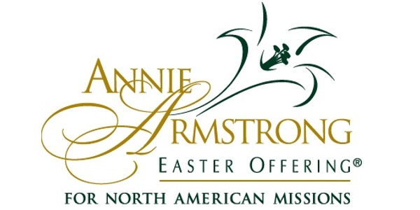

K s b c

Keeping His Word through Sunday School, Bible Study and Church Attendance/Worship

Sunday School Bible Studies for March:

Mar. 1st Promised Like No Other Isaiah 53:2-12 Mar. 8th A Birth Like No Other Luke 1:26-35
Mar. 15th Power Like No Other Mark 4:35-41
Mar. 22nd Teachings Like No Other Mark 1:21-22; 10:17-22
Mar. 29th A Death Like No Other Mathew 27:28-31, 45-50, 54

9:45 a.m. each Sunday – A place for everyone

WE’D LOVE FOR YOU TO JOIN US!

